1 Product description
2 Related material

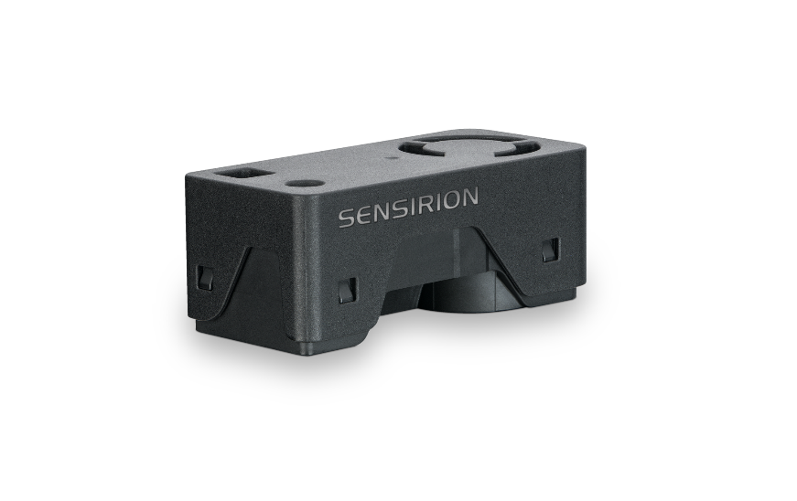
1 Product description
SEN65 - Sensing platform for PM, RH/T, VOC and NOx measurements
Experience the future of air quality sensing with the compact and powerful SEN65. It combines multiple sensors in a never-before-seen form factor and can measure up to eight environmental parameters (PM1, PM2.5, PM4, PM10, T, RH, VOC Index, NOx Index). The innovative design simplifies integration, reduces costs and allows for customization. At the core of the SEN65 is a brand-new, miniaturized, MEMS-based particulate matter sensing component – the SPS6x.
Features:
- All-in-one air quality sensor module
- RH/T, PM (1, 2.5, 4, 10), VOC and NOx outputs
- On-board algorithms
- Compliant with IAQ standards RESET®, WELL Building Standard™ and California Title 24 Building Energy Efficiency Standards

Benefits:
- Combination of multiple sensors
- Compact form factor
- Simplified integration
- Cost-efficient
- Short time to market

Applications:
- Indoor air quality monitoring
- Vape detection
- Smart buildings
- Room sensors
- Air purifiers

Applications requiring compliance with IAQ standards – such as RESET®, WELL Building Standard™ and California Title 24 Building Energy Efficiency Standards – are well served by the SEN6x.
SEN63C - Sensing platform for PM, RH/T and CO2 measurements
Experience the future of air quality sensing with the compact and powerful SEN63C. It combines multiple sensors in a never-before-seen form factor and can measure up to nine environmental parameters (PM1, PM2.5, PM4, PM10, T, RH, CO2). The innovative design simplifies integration, reduces costs, and allows for customization through the different variants within the SEN6x family. At the core of the SEN63C is a brand-new, miniaturized, MEMS-based particulate matter sensing component – the SPS6x. Applications requiring compliance with IAQ standards – such as RESET® and WELL Building Standard™ Building Energy Efficiency Standards – are well served by the SEN63C (CO2 not compliant, see SEN66 instead for CO2 conformance).
Features:
- All-in-one air quality sensor module
- RH/T, PM (1, 2.5, 4, 10), CO2 outputs
- On-board algorithms
- Compliant with IAQ standards RESET®, WELL Building Standard™ and California Title 24 Building Energy Efficiency Standards

Benefits:
- Combination of multiple sensors
- Compact form factor
- Simplified integration
- Cost-efficient
- Short time to market

Applications:
- Indoor air quality monitoring
- Vape detection
- Smart buildings
- Room sensors
- Air purifiers

Applications requiring compliance with IAQ standards – such as RESET®, WELL Building Standard™ and California Title 24 Building Energy Efficiency Standards – are well served by the SEN6x.

SEK-SEN63C Evaluation kit SEN63C
- All-in-one air quality sensor module
- RH/T, PM (1, 2.5, 4, 10) and CO2 outputs
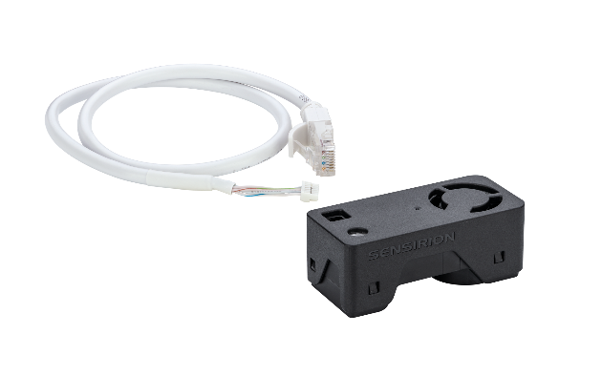
- On-board algorithms

Includes:

- 1x SEN63C
- 1x adapter cable
- 1x jumper wire set
- 1x adapter cabel Qwiic
- 1x SEK-SensorBridge required

2 Related material
- Product launch package: SEN65, SEN63C and SEK-SEN63C - NPIs - PARTNERS @ Sensirion
- SEN63C product page: SEN63C - Sensing platform for PM, RH/T and CO2 measurements
- SEK-SEN63C product page: SEK-SEN63C - Evaluation kit SEN63C
- SEN65 product page: SEN65 - Sensing platform for PM, RH/T, VOC and NOx measurements
- SEK-SEN66 product page: SEK-SEN66-Evaluation kit SEN60, SEN65, SEN66 (sensirion.com)
- Datasheet: https://sensirion.com/resource/datasheet/SEN6x
- Application notes:
  - How can I integrate Sensirion’s VOC and NOx sensors into my air purifier? https://sensirion.com/resource/application_note/voc_nox_sensor_integration
  - Is it possible to map the output of a MOX sensor to a norm? https://sensirion.com/resource/application_note/output_mox_sensor
  - What are oxidizing gases? https://sensirion.com/resource/application_note/oxidizing_gases
  - What are reducing gases? https://sensirion.com/resource/application_note/reducing_gases
  - What is a metal oxide (MOX) sensor? https://sensirion.com/resource/application_note/mox_sensor
  - What is Sensirion’s NOx Index? https://sensirion.com/resource/application_note/nox_index
  - What is Sensirion’s VOC Index? https://sensirion.com/resource/application_note/voc_index
  - Compliance of Sensirion’s VOC Sensors with RESET and WELL: https://sensirion.com/resource/application_note/compliance_VOC_sensors_building_standards
  - SEN6x – Mechanical design and assembly guidelines: https://sensirion.com/resource/application_note/SEN6x_mechanical_design_assembly_guidelines
- REACH and RoHS declaration: https://sensirion.com/resource/certificate/pm/reach_rohs
- One-pager vape detection: https://partners.sensirion.com/share/eYTX1VpK8R8Pcvkmja19
- One-pager air purifier: https://partners.sensirion.com/share/srCL8Xq6tie99TvSe57n
- One-pager IAQ monitors: https://partners.sensirion.com/share/Tm9b7nzaNXWhEoh8QqHf
- Particulate matter flyer: https://sensirion.com/resource/flyer-pm
- IAQ brochure: https://sensirion.com/resource/flyer/iaq/brochure
- Pictures SEN6x (no Login required):
  - SEN6x: https://brand.sensirion.com/share/4BDokbi7iPGqTqSwMEGY
  - SEN6x (shadow): https://brand.sensirion.com/share/BVTvFJD67Lu7vPxvQW51
  - SEK-SEN6x (plugged in): https://partners.sensirion.com/share/sBfK8UcDsgmZvXyX7XTm
  - SEK-SEN6x (plugged out): https://partners.sensirion.com/share/syTsJAKdHYSt6TjpCH6G
  - SEK-SEN6x cables: https://partners.sensirion.com/share/hWbNTJ45fgmPraq9zPDA

