1 产品描述
2 相关资料

产品描述
SEK-STC42A - STC42A评估套件

SEK-STC42A 为 STC42A 氢气传感器的评估与原型开发套件。该套件提供完整的接口与运行支持，可用于快速验证传感器性能、加速开发流程及支持初步系统集成测试。
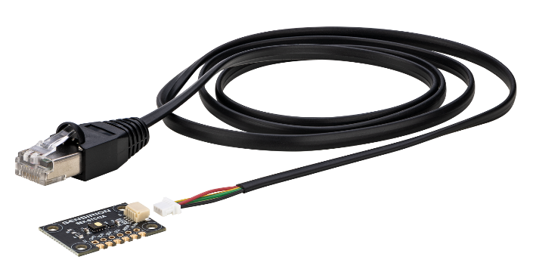

典型应用:

- 电池热失控监测验证
- 氢气泄漏监测系统原型开发
- 热扩散与安全测试实验

2 相关资料
- Product launch package: SEK-STC42A - NPIs - PARTNERS @ Sensirion
- SEK-STC42A product page: SEK-STC42A - Evaluation kit for H₂ sensor STC42A
- STC42A product page: STC42A - Automotive H₂ sensor for thermal runaway detection
- Quick start guide SEK-STC42A: https://sensirion.com/resource/user_guide/quick_start_SEK-STC42A
- REACH and RoHS declaration: https://sensirion.com/resource/certificate/stc/rohs_reach_hal_free
- Pictures Sek-STC42A (no Login required):
  - SEK-STC42A plugged: https://brand.sensirion.com/share/ggPpi2gHR5y194uzUr3i
  - SEK-STC42A plugged (shadow): https://brand.sensirion.com/share/gbCMtqoLksrJihW6nC6v
  - SEK-STC42A unplugged: https://brand.sensirion.com/share/QJdKWV6Q827kpxjngGAs
  - SEK-STC42A unplugged (shadow): https://brand.sensirion.com/share/BBXbnFzydQ1uA3ufiYt3

