1 Product description
2 Related material

1 Product description
SHT43 humidity and temperature sensor demonstrator
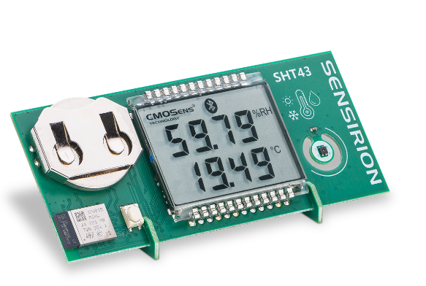
The SHT43 DemoBoard is a compact demonstrator showcasing the exceptional performance and user-friendliness of our SHT4x humidity and temperature sensors, along with the ISO17025 certificate support for the SHT43 sensor.
Featuring an LCD display presenting humidity and temperature data, this device also includes a Bluetooth Low Energy module for communication with smartphones and other compatible devices.
Compatible with our MyAmbience mobile app, the SHT43 DemoBoard allows users to visualize and understand their surroundings by displaying live data, tracking historical trends, identifying patterns, and exporting data from multiple devices. Find more information and MyAmbience download links in the section below.

Features:
- SHT43 Humidity and Temperature Sensor with ISO17025 calibration
- Individual temperature calibration certificate
- LCD Display for relative humidity, temperature and Dew point measurements (°C and °F)
- Bluetooth Low Energy (BLE) connectivity to iOS and Android Smartphones
- Data Logging capabilities

ISO17025 Temperature Calibration
- Required for regulatory compliance in industries such as Pharma, Food & Beverages and Medical Devices
- Provides internationally recognized proof of measurement accuracy and consistency
- Integration into data loggers and cold-chain trackers and monitors

MyAmbience – App

Connect your Sensirion Smart Gadget via Bluetooth to your mobile device and get to know your environment.
MyAmbience enables you to:
- View live-data from all your gadgets
- Download the calibration certificate of the SHT43 sensor mounted on your DemoBoard
- Track measurements history and export all your data
- Data visualization and sharing

2 Related material
- SHT43 DemoBoard product page: SHT43 DemoBoard - SHT43 humidity and temperature sensor demonstrator
- SHT43 DemoBoard user guide: https://sensirion.com/resource/user_guide/sht43_domoboard
- REACH and RoHS declaration: https://sensirion.com/resource/certificate/sht/rohs_reach_hal-free
- Testing at ambient conditions SHT – application note: https://sensirion.com/resource/application_note/testing_ambient_conditions/sht
- Software:
  - MyAmbiance iOS Download: https://apps.apple.com/ch/app/sensirion-myambience/id1529131572?l=en
  - MyAmbiance Android Download: https://play.google.com/store/apps/details?id=com.sensirion.myam&hl=en&gl=CH
  - SHT43 DemoBoard Firmware: https://sensirion.com/resource/software/sht43_domoboard_firmware
  - SHT43 DemoBoard Over-the-Air Update Firmware: https://sensirion.com/resource/software/sht43_demoboard_over-the-air_update_firmware
- Picture SHT43 DemoBoard (no Login required): https://brand.sensirion.com/share/CjcQDnPCgpXVhf6MFmXm

