1 产品描述
2 相关资料

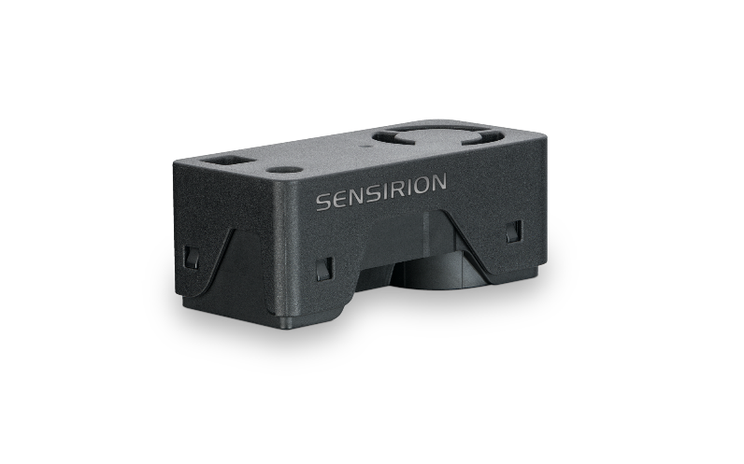
产品描述
SEN62 - PM, RH/T测量传感器平台

通过小巧而强大的SEN66传感器平台体验空气质量传感的未来。SEN62以前所未有的紧凑外形集成了多个传感器，可以测量多达9种环境参数(PM1, PM2.5, PM4, PM10, T, RH)，其核心组件是一颗全新小型化的，基于mems技术的颗粒物传感器——SPS6x。创新的设计大大简化了集成，降低了成本，并支持定制。

特点:
- 多合一空气质量传感器模组
- 板载算法
- 符合RESET®、WELL Building Standard™和
优势：
- 多合一传感器模组
- 外形紧凑
- 简化集成
- 成本效益高
- 快速上市

应用：
- 复印机
- 3D打印机
- 空气净化器

SEN6x 能够很好地满足需要符合相关 IAQ 标准的应用。（如 RESET®、WELL Building Standard™和California Title 24 Building Energy Efficiency Standards）

2 相关资料
- Product launch package: SEN62 - NPIs - PARTNERS @ Sensirion
- SEN62 product page: SEN62 - Sensing platform for PM and RH/T measurements
- Datasheet: https://sensirion.com/resource/datasheet/SEN6x
- Application notes:
  - https://sensirion.com/resource/application_note/compliance_VOC_sensors_building_standards
  - https://sensirion.com/resource/application_note/SEN6x_mechanical_design_assembly_guidelines
- Guides:
  - https://sensirion.com/resource/sen6x-limits
  - https://sensirion.com/resource/sen6x-handling
  - https://sensirion.com/resource/sen6x-int-heater
  - https://sensirion.com/resource/sen6x-spec-statement
  - https://sensirion.com/resource/SEN6x-temp-compensation
- REACH and RoHS declaration: https://sensirion.com/resource/certificate/pm/reach_rohs
- Particulate matter flyer: https://sensirion.com/resource/flyer-pm
- IAQ brochure: https://sensirion.com/resource/flyer/iaq/brochure
- Pictures SEN6x (no Login required):
  - SEN6x: https://brand.sensirion.com/share/4BDokbi7iPGqTqSwMEGY
  - SEN6x (shadow): https://brand.sensirion.com/share/BVTvFJD67Lu7vPxvQW51
  - SEK-SEN6x (plugged in): https://partners.sensirion.com/share/sBfK8UcDsgmZvXyX7XTm
  - SEK-SEN6x (plugged out): https://partners.sensirion.com/share/syTsJAKdHYSt6TjpCH6G
  - SEK-SEN6x cables: https://partners.sensirion.com/share/hWbNTJ45fgmPraq9zPDA

