1 Product description
2 Related material

1 Product description
STS41A Automotive grade ±0.2°C temperature sensor with wettable flanks and I2C address output
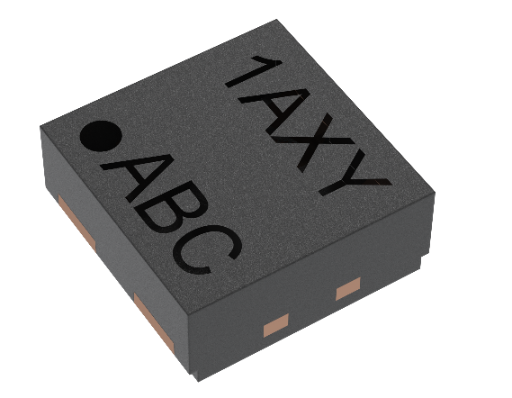
The STS4xA is Sensirion’s highly reliable, automotive-grade digital temperature sensor series. The STS41A includes wettable flanks packaging to support automated optical inspection (AOI). Moreover, the integrated on-chip heater enables advanced on-board diagnosis (OBD). The sensor platform is based on Sensirion’s CMOSens® Technology and extensive experience in temperature sensing, and it benefits from the company’s well-established engineering expertise. The cost-efficient STS4xA features an I²C interface and provides a wide supply voltage range of 1.08 - 3.6 V. Thanks to its small size and the four-pin dual-flat no-leads (DFN) package, the STS4xA can easily be integrated into a variety of automotive applications. It has been specifically designed for automotive applications and fulfills demanding reliability requirements, such as 85°C/85%RH accelerated life tests and the AEC Q100 qualification.
Sensor features:
- enhanced signal processing
- two distinctive I²C addresses
- Automotive grade qualified
- Wettable flanks
- On-board diagnostics (OBD) capable
- Integrated heater

Benefits:
- designed for mass production
- high signal-to-noise ratio
- high process capability
- proven record of long-term reliability and stability

Applications:
The STS41A is easy to integrate into a variety of automotive or safety or in general, high reliability needed applications. With its wide supply voltage range and low power consumption enable applications such as Radar, Camera, Lidar or steer.by-wire applications.

2 Related material
- Product launch package: STS41A - NPIs - PARTNERS @ Sensirion
- STS41A-AWBL product page: STS41A-AWLB - Automotive grade ±0.2°C temperature sensor with wettable flanks and I2C 0x44 address output
- STS41A-BWLB product page: STS41A-BWLB - Automotive grade ±0.2°C temperature sensor with wettable flanks and I2C 0x45 address output
- Datasheet: https://sensirion.com/resource/datasheet/sts4xa
- REACH and RoHS declaration: https://sensirion.com/resource/certificate/sht/rohs_reach_hal-free
- Handling instructions STS: https://sensirion.com/resource/sts/handling_instructions
- Design guide SHT/STS: https://sensirion.com/resource/user_guide/sht/design_in
- Arduino driver I2C STS4x: https://sensirion.com/resource/software/arduino/i2c/sts40
- Embedded drivers temperature: https://sensirion.com/resource/software/driver/sts/embedded
- Temperature sensor brochure: https://sensirion.com/resource/flyer/temperature_sensors
- Picture (no Login required): https://brand.sensirion.com/share/UhR9Lfr3qv9VdPhReut1

