1 Product description
2 Related material

Product description
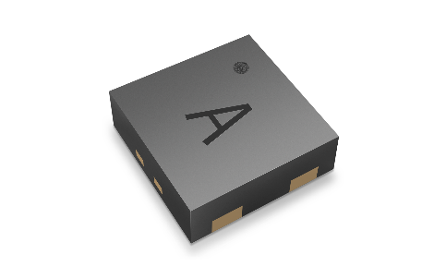
STS4L ±0.4°C Ultra-low-power temperature sensor

The STS4L is a fully digital, highly cost-effective temperature sensor that provides the accuracy required for most applications. With a footprint of just 1.5 × 1.5 x 0.5 mm, it is easy to integrate into a variety of applications, and its wide supply voltage range and low power consumption enable battery-powered designs.

Sensor features:
- enhanced signal processing
- three distinctive I²C addresses
- communication speeds of up to 1 MHz

Benefits:
- designed for mass production
- high signal-to-noise ratio
- high process capability
- proven record of long-term reliability and stability

Applications:
The STS4L is easy to integrate into a variety of applications, and its wide supply voltage range and low power consumption enable battery-powered designs.

Related material
- Product launch package: STS4L - NPIs - PARTNERS @ Sensirion
- STS4L: STS4L-±0.4°C Ultra-low-power temperature sensor (sensirion.com)
- SEK-STS40: SEK-STS40-CD1B-Temperature evaluation kit STS40 (sensirion.com)
- Datasheet STL4L: https://sensirion.com/resource/datasheet/sts4x
- REACH and RoHS declaration: https://sensirion.com/resource/certificate/sht/rohs_reach_hal-free
- Design guide SHT/STS: https://sensirion.com/resource/user_guide/sht/design_in
- Temperature sensor brochure: https://sensirion.com/resource/flyer/temperature_sensors
- Picture STS4L (no Login required): STS4x Lasermarking Big Shadow (2000x1250) - Frontify (sensirion.com)

