1 Product description
2 Related material

1 Product description
STC42x – H₂ leakage sensor from the market leader for thermal conductivity
Thermal conductivity sensor to monitor hydrogen emissions to detect early signs of thermal runaway in batteries of Electric Vehicles (EVs), Fuel Cell Vehicles (FCVs) and Battery Energy Storage Systems (BESS) or leakages of hydrogen systems such as hydrogen production plants, storage tanks or pipelines.

Features:
- Field-Proven Technology
- Outstanding Long-Term Stability
- Cost-Efficient, Highly Integrated Design

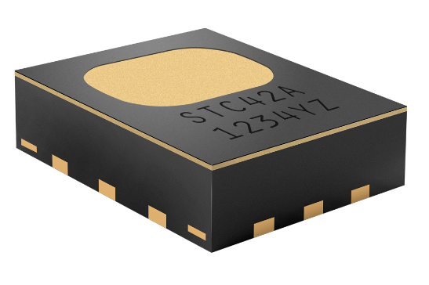
STC42A - Automotive H2 sensor for thermal runaway detection.
With its unmatched stability, performance and reliability, STC42A is the perfect choice for hydrogen detection, both in battery thermal runaway and hydrogen leakage applications.

Related applications:
- Battery thermal runaway detection
- Hydrogen leakage
- Thermal Propagation

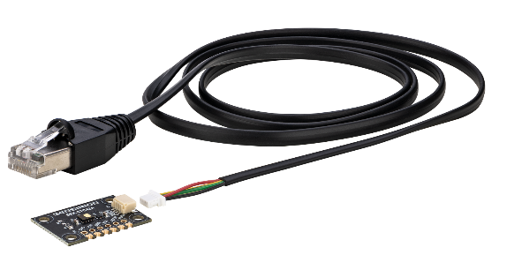
SEK-STC42A - Evaluation kit for H₂ sensor STC42A

The SEK-STC42A evaluation kit represents the perfect tool kit for effective STC42A sensor evaluation and efficient prototyping.

Related applications
- Battery thermal runaway detection
- Hydrogen leakage
- Thermal Propagation

2 Related material
- Product launch package: STC42A - NPIs - PARTNERS @ Sensirion
- STC42A product page: STC42A - Automotive H₂ sensor for thermal runaway detection
- Quick start guide SEK-STC42A: https://sensirion.com/resource/user_guide/quick_start_SEK-STC42A
- Datasheet STC42A: https://sensirion.com/resource/datasheet/STC42A
- REACH and RoHS declaration: https://sensirion.com/resource/certificate/stc/rohs_reach_hal_free
- Article battery state monitoring: https://sensirion.com/forms/article-battery-state-monitoring
- Pictures STC42A (no Login required):
  - STC42A: https://brand.sensirion.com/share/5pWhTiduJsPMYCE6WPf2
  - STC42A (shadow): https://brand.sensirion.com/share/H45odjqyxxt6yxVyy3kz

