1 产品描述
2 相关资料

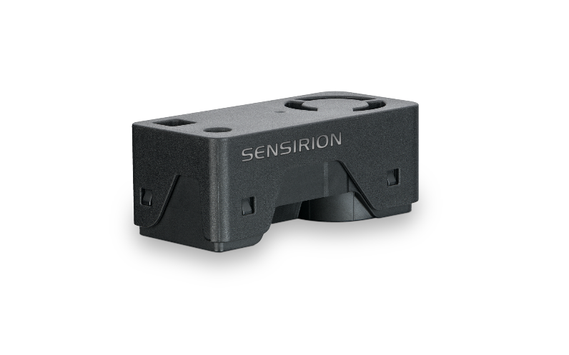
产品描述
SEN65 - PM, RH/T, VOC和NOx测量传感器平台

通过小巧而强大的SEN65传感器平台体验空气质量传感的未来。SEN65以前所未有的紧凑外形集成了多个传感器，可以测量多达8个环境参数(PM1, PM2.5, PM4, PM10, T, RH, VOC指数，NOx指数) ，其核心组件是一颗全新小型化的，基于mems技术的颗粒物传感器——SPS6x。创新的设计大大简化了集成，降低了成本。SEN65适配需要符合不同室内空气质量标准的应用，如RESET®，WELL建筑标准™和California Title 24建筑能效标准。

特点:
- 多合一空气质量传感器模组
- RH/T、PM（1、2.5、4、10）、VOC 和 NOx
- 板载算法
- 符合RESET®、WELL Building Standard™和California Title 24 Building Energy Efficiency Standard等室内空气质量标准

优势：
- 多合一传感器模组
- 外形紧凑
- 简化集成
- 成本效益高
- 快速上市

应用：
- 室内空气质量监测
- 电子烟检测
- 智能建筑
- 室内传感器
- 空气净化器

SEN6x 能够很好地满足需要符合相关 IAQ 标准的应用。（如 RESET®、WELL Building Standard™和California Title 24 Building Energy Efficiency Standards）

SEN63C – 用于颗粒物、温湿度和二氧化碳测量的传感平台

通过小巧而强大的SEN63C传感器平台体验空气质量传感的未来。SEN63C以前所未有的紧凑外形集成了多个传感器，可以测量多达7个环境参数(PM1, PM2.5, PM4, PM10, T, RH, CO2) ，其核心组件是一颗全新小型化的，基于mems技术的颗粒物传感器——SPS6x。创新的设计大大简化了集成，降低了成本。SEN63C适配需要符合不同室内空气质量标准的应用，如RESET®，WELL建筑标准™和California Title 24建筑能效标准。

特点:
- 多合一空气质量传感器模组
- RH/T、PM（1、2.5、4、10）、VOC 和 NOx、CO2 输出
- 板载算法
- 符合RESET®、WELL Building Standard™和California Title 24 Building Energy Efficiency Standard等室内空气质量标准

优势：
- 多合一传感器模组
- 外形紧凑
- 简化集成
- 成本效益高
- 快速上市

应用：
- 室内空气质量监测
- 电子烟检测
- 智能建筑
- 室内传感器
- 空气净化器

SEN6x 能够很好地满足需要符合相关 IAQ 标准的应用。（如 RESET®、WELL Building Standard™和California Title 24 Building Energy Efficiency Standards）

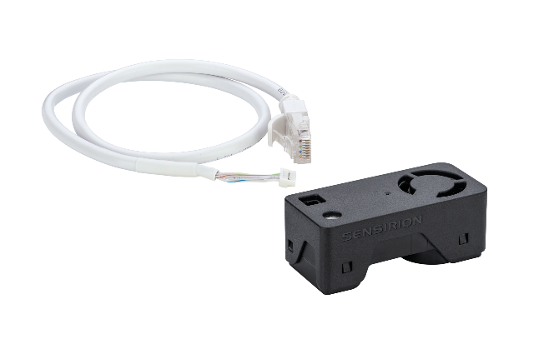
SEN63C 评估套件

多合一空气质量传感器模组

包括

1x SEN63C
1x 适配电缆

1x 跨接电缆
1x Qwiic 适配电缆
需另配 1x SEK-SensorBridge

2 相关资料
- Product launch package: SEN65, SEN63C and SEK-SEN63C - NPIs - PARTNERS @ Sensirion
- SEN63C product page: SEN63C - Sensing platform for PM, RH/T and CO2 measurements
- SEK-SEN63C product page: SEK-SEN63C - Evaluation kit SEN63C
- SEN65 product page: SEN65 - Sensing platform for PM, RH/T, VOC and NOx measurements
- SEK-SEN66 product page: SEK-SEN66-Evaluation kit SEN60, SEN65, SEN66 (sensirion.com)
- Datasheet: https://sensirion.com/resource/datasheet/SEN6x
- Application notes:
  - How can I integrate Sensirion’s VOC and NOx sensors into my air purifier? https://sensirion.com/resource/application_note/voc_nox_sensor_integration
  - Is it possible to map the output of a MOX sensor to a norm? https://sensirion.com/resource/application_note/output_mox_sensor
  - What are oxidizing gases? https://sensirion.com/resource/application_note/oxidizing_gases
  - What are reducing gases? https://sensirion.com/resource/application_note/reducing_gases
  - What is a metal oxide (MOX) sensor? https://sensirion.com/resource/application_note/mox_sensor
  - What is Sensirion’s NOx Index? https://sensirion.com/resource/application_note/nox_index
  - What is Sensirion’s VOC Index? https://sensirion.com/resource/application_note/voc_index
  - Compliance of Sensirion’s VOC Sensors with RESET and WELL: https://sensirion.com/resource/application_note/compliance_VOC_sensors_building_standards
  - SEN6x – Mechanical design and assembly guidelines: https://sensirion.com/resource/application_note/SEN6x_mechanical_design_assembly_guidelines
- REACH and RoHS declaration: https://sensirion.com/resource/certificate/pm/reach_rohs
- One-pager vape detection: https://partners.sensirion.com/share/eYTX1VpK8R8Pcvkmja19
- One-pager air purifier: https://partners.sensirion.com/share/srCL8Xq6tie99TvSe57n
- One-pager IAQ monitors: https://partners.sensirion.com/share/Tm9b7nzaNXWhEoh8QqHf
- Particulate matter flyer: https://sensirion.com/resource/flyer-pm
- IAQ brochure: https://sensirion.com/resource/flyer/iaq/brochure
- Pictures SEN6x (no Login required):
  - SEN6x: https://brand.sensirion.com/share/4BDokbi7iPGqTqSwMEGY
  - SEN6x (shadow): https://brand.sensirion.com/share/BVTvFJD67Lu7vPxvQW51
  - SEK-SEN6x (plugged in): https://partners.sensirion.com/share/sBfK8UcDsgmZvXyX7XTm
  - SEK-SEN6x (plugged out): https://partners.sensirion.com/share/syTsJAKdHYSt6TjpCH6G
  - SEK-SEN6x cables: https://partners.sensirion.com/share/hWbNTJ45fgmPraq9zPDA

