1 产品描述
2 相关资料

产品描述
SEK-SEN66多合一空气质量传感器模组评估套件（适用于SEN60, SEN65, SEN66）

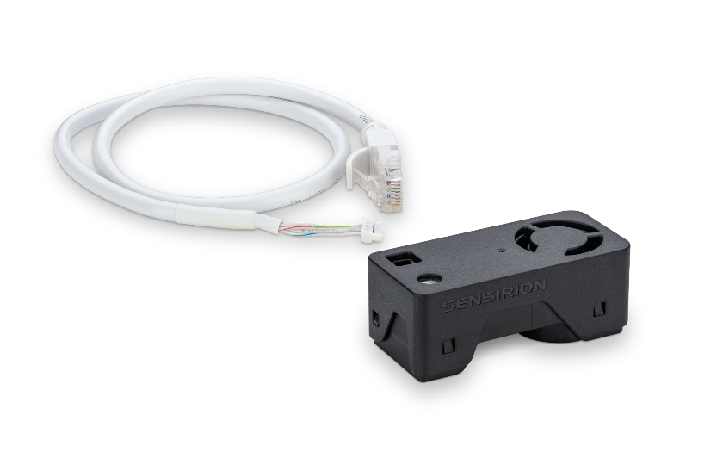
通过小巧而强大的SEN66传感器模组体验空气质量传感的未来。SEN66以前所未有的紧凑外形集成了多个传感器，可以测量多达9种环境参数(PM1, PM2.5, PM4, PM10, T, RH, VOC指数，NOx指数，CO2)，其核心组件是一颗全新小型化的，基于mems技术的颗粒物传感器——SPS6x。创新的设计大大简化了集成，降低了成本，同时支持通过SEN6x系列中的不同传感器进行定制。

SEK-SEN66 评估套件适用于对Sensirion 多合一空气质量传感器模组SEN66、SEN65 和 SEN60 进行简单且经济高效的评估。

套件包含一个 SEN66 多合一空气质量传感器模组和一条适配电缆，可将 SEN66 连接到 SEK-SensorBridge，可轻松通过 Sensirion 的 SEK-ControlCenter 查看器软件进行评估。此外，还包括用于 Qwiic 的一套跳线和一条适配电缆，可通过集成到 Arduino、Raspberry Pi 等现有平台实现快速原型开发。同时，Sensirion 还为这些平台提供了驱动程序。

请注意：SEK-SensorBridge 不包含在评估套件中，需单独订购。

特点:
- 多合一空气质量传感器模组
- RH/T、PM（1、2.5、4、10）、VOC 和 NOx、CO2 输出
- 板载算法
- 符合RESET®、WELL Building Standard™和California Title 24 Building Energy Efficiency Standard等室内空气质量标准

优势：
- 多合一传感器模组
- 外形紧凑
- 简化集成
- 成本效益高
- 快速上市

应用：
- 室内空气质量监测
- 电子烟检测
- 智能建筑
- 室内传感器
- 空气净化器

SEN66 能够很好地满足需要符合相关 IAQ 标准的应用。（如 RESET®、WELL Building Standard™和California Title 24 Building Energy Efficiency Standards

相关资料
- Product launch package: SEK-SEN66 - NPIs - PARTNERS @ Sensirion
- SEK-SEN66: SEK-SEN66-Evaluation kit SEN60, SEN65, SEN66 (sensirion.com)
- SEN66 product page: SEN66-Sensing platform for PM, RH/T, VOC, Nox and CO2 measurements (sensirion.com)
- SEN65 product page: SEN65-Sensing platform for PM, RH/T, VOC and NOx measurements (sensirion.com)
- SEN60 product page: SEN60-Sensing platform for PM measurements (sensirion.com)
- Datasheet: https://sensirion.com/resource/datasheet/SEN6x
- Application notes:
  - How can I integrate Sensirion’s VOC and NOx sensors into my air purifier? https://sensirion.com/resource/application_note/voc_nox_sensor_integration
  - Is it possible to map the output of a MOX sensor to a norm? https://sensirion.com/resource/application_note/output_mox_sensor
  - What are oxidizing gases? https://sensirion.com/resource/application_note/oxidizing_gases
  - What are reducing gases? https://sensirion.com/resource/application_note/reducing_gases
  - What is a metal oxide (MOX) sensor? https://sensirion.com/resource/application_note/mox_sensor
  - What is Sensirion’s NOx Index? https://sensirion.com/resource/application_note/nox_index
  - What is Sensirion’s VOC Index? https://sensirion.com/resource/application_note/voc_index
  - Compliance of Sensirion’s VOC Sensors with RESET and WELL: https://sensirion.com/resource/application_note/compliance_VOC_sensors_building_standards
- REACH and RoHS declaration: https://sensirion.com/resource/certificate/pm/reach_rohs
- Particulate matter flyer: https://sensirion.com/resource/flyer-pm
- Pictures SEK-SEN6x (no Login required):
  - SEK-SEN66 plugged out: https://brand.sensirion.com/share/syTsJAKdHYSt6TjpCH6G
  - SEK-SEN66 plugged out (with shadow): https://brand.sensirion.com/share/KgKpsUnNpmLYFPtqPC6J
  - SEK-SEN66 plugged-in: https://brand.sensirion.com/share/sBfK8UcDsgmZvXyX7XTm
  - SEK-SEN66 plugged-in (with shadow): https://brand.sensirion.com/share/pmAwL1WB9vUaMFjn5Prp
  - SEK-SEN66 cables: https://brand.sensirion.com/share/hWbNTJ45fgmPraq9zPDA
  - SEK-SEN66 cables (with shadow): https://brand.sensirion.com/share/nk6Q7UueWBpaq7J72hRt

