1 Product description
2 Related material

1 Product description
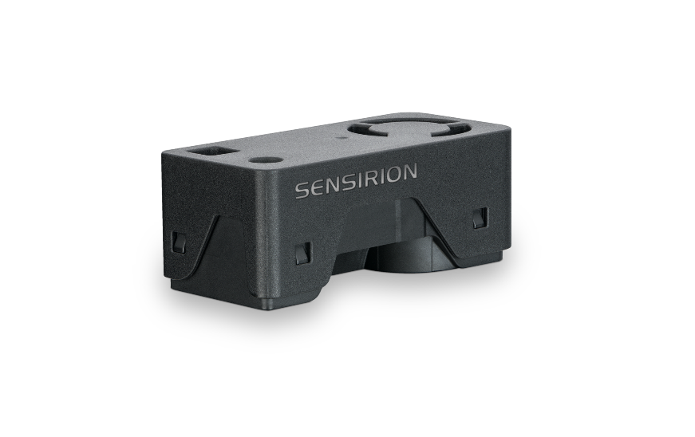
Simplifying indoor air quality sensing with the SEN66 sensing platform for PM, RH/T, VOC, Nox and CO2 measurements
Experience the future of air quality sensing with the compact and powerful SEN66. It combines multiple sensors in a never-before-seen form factor and can measure up to nine environmental parameters (PM1, PM2.5, PM4, PM10, T, RH, VOC Index, NOx Index, CO2). The innovative design simplifies integration, reduces costs, and allows for customization through the different variants within the SEN6x family. At the core of the SEN66 is a brand-new, miniaturized, MEMS-based particulate matter sensing component – the SPS6x.
Features:
- All-in-one air quality sensor module
- RH/T, PM (1, 2.5, 4, 10), VOC and NOx, CO2 outputs
- On-board algorithms
- Compliant with IAQ standards RESET®, WELL Building Standard™ and California Title 24 Building Energy Efficiency Standards

Benefits:
- Combination of multiple sensors
- Compact form factor
- Simplified integration
- Cost-efficient
- Short time to market

Applications:
- Indoor air quality monitoring
- Vape detection
- Smart buildings
- Room sensors
- Air purifiers

Applications requiring compliance with IAQ standards – such as RESET®, WELL Building Standard™ and California Title 24 Building Energy Efficiency Standards – are well served by the SEN66.

2 Related material
- SEN66 product page: SEN66-Sensing platform for PM, RH/T, VOC, Nox and CO2 measurements (sensirion.com)
- SEK-SEN66: SEK-SEN66-Evaluation kit SEN60, SEN65, SEN66 (sensirion.com)
- Datasheet: https://sensirion.com/resource/datasheet/SEN6x-distribution
- Application notes:
  - How can I integrate Sensirion’s VOC and NOx sensors into my air purifier? https://sensirion.com/resource/application_note/voc_nox_sensor_integration
  - Is it possible to map the output of a MOX sensor to a norm? https://sensirion.com/resource/application_note/output_mox_sensor
  - What are oxidizing gases? https://sensirion.com/resource/application_note/oxidizing_gases
  - What are reducing gases? https://sensirion.com/resource/application_note/reducing_gases
  - What is a metal oxide (MOX) sensor? https://sensirion.com/resource/application_note/mox_sensor
  - What is Sensirion’s NOx Index? https://sensirion.com/resource/application_note/nox_index
  - What is Sensirion’s VOC Index? https://sensirion.com/resource/application_note/voc_index
  - Compliance of Sensirion’s VOC Sensors with RESET and WELL: https://sensirion.com/resource/application_note/compliance_VOC_sensors_building_standards
  - Sensor specification statement Particulate Matter Sensors: https://sensirion.com/resource/application_note/pm/sensor_specification
- REACH and RoHS declaration: https://sensirion.com/resource/certificate/pm/reach_rohs
- Particulate matter flyer: https://sensirion.com/resource/flyer-pm
- IAQ brochure : https://sensirion.com/resource/flyer/iaq/brochure
- Pictures SEK-SEN6x (no Login required):
  - SEN66: https://brand.sensirion.com/share/BVTvFJD67Lu7vPxvQW51
  - SEN66(with shadow): https://brand.sensirion.com/share/4BDokbi7iPGqTqSwMEGY

