1 Product description
2 Related material
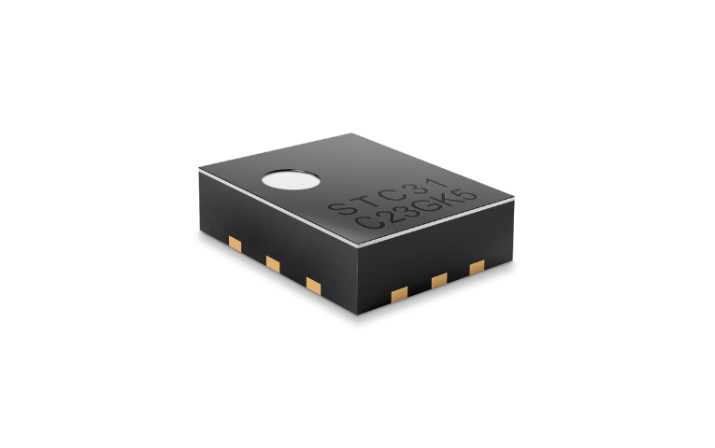

Product description
The STC31-C is a chip-sized gas concentration sensor for high range, accurate CO₂measurements designed for high-volume production.

The sensor is based on a revolutionized thermal conductivity measurement principle, which results in superior repeatability and long-term stability. This makes the STC31-C the perfect choice for applications where reliability is key. Thermal conductivity technology has an ultra-low power consumption, even compared to low-power optical sensor. This makes it the ideal choice for battery operated applications, delivering top-performance at an absolute minimal power budget.

Sensor features:
- ultra-low power consumption
- digital I²C interface
- outstanding performance through patented CMOSens® Technology

Benefits:
- perfectly suited for high-quality mass production
- ideal choice for demanding and cost-sensitive OEM applications

Applications:
- Breath analyzer
- Transportation of goods

Sensor evaluation SEK-STC31-C:
- Perfectly suited for measuring high CO₂ concentrations
- Reliable sensor output over product lifetime
- Fast, automated and low-cost assembly

Includes:
- 1x STC31-C,1x SHTC3 on FPCB
- 1x RJ45 adapter cable (1 meter length)

- 1x SEK-SensorBridge required

Related material
- Product launch package:
https://partners.sensirion.com/document/139#/co2/stc31-c-1
- STC31-C: https://sensirion.com/products/catalog/STC31-C
- SEK-STC31-C : https://sensirion.com/products/catalog/SEK-STC31-C
- Datasheet STC31-C: https://sensirion.com/resource/datasheet/stc31-c
- REACH and RoHS declaration: https://sensirion.com/resource/certificate/stc/rohs_reach_hal_free
- Design guide STC31-C: https://sensirion.com/resource/application_note/design_guide_STC31-C
- Handling and assembly guide: https://sensirion.com/resource/user_guide/stc31/handling_assembly
- Pictures (no Login required):
  - STC31-C: https://brand.sensirion.com/share/oiGSVYofiBaaNUKrTtVp
  - SEK STC31-C: https://brand.sensirion.com/share/SZJA3hzf4UroR1RTxQ7f

