1 Product description
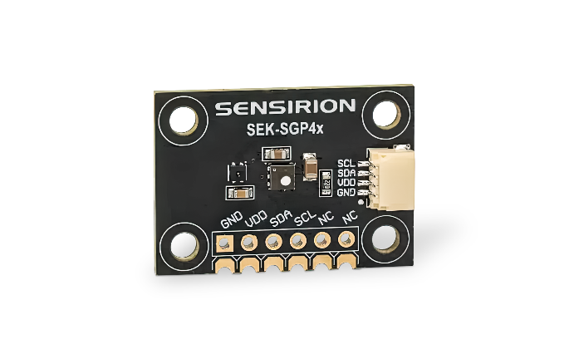
2 Related material

1 Product description
SEK-SGP4x evaluation kit for SGP40 and SGP41 VOC and NOx gas sensors
The SEK-SGP4x sensor evaluation kit is designed for engineers and developers to quickly prototype and integrate Sensirion’s VOC and NOx gas sensors into their applications. It supports both SGP40 and SGP41 sensor operation modes and includes a combined SHT41 humidity and temperature sensor. Unlike the SEK-SVM4x evaluation kit, this breakout board has no onboard microcontroller and outputs only raw sensor values (SRAW). To obtain VOC and NOx Index or other processed signals, the SEK-SGP4x board can be connected to PC using Sensirion’s SEK-SensorBridge and read out with the SEK-ControlCenter software.
Features:
- Fast sensor evaluation and easy prototyping
- Detecting various indoor gas pollutants on a single sensor chip
- Compliant with the relevant healthy building standards RESET® and WELL Building Standard™

Includes:
- 1x SGP4x development board
- 1x adapter cable
- 1x jumper wire set

Applications:
- Air Purifier
- Other air treatment devices and indoor air quality monitors

2 Related material
- Product launch package: https://partners.sensirion.com/document/139#/voc-and-nox/sek-sgp4x-1
- SEK-SGP4x product page: https://sensirion.com/products/catalog/SEK-SGP4x
- Datasheet SGP40: https://sensirion.com/resource/datasheet/sgp40
- Datasheet SGP41: https://sensirion.com/resource/datasheet/sgp41
- Application notes:
  - https://sensirion.com/resource/application_note/compliance_VOC_sensors_building_standards
  - https://sensirion.com/resource/application_note/improve_air_quality
  - https://sensirion.com/resource/application_note/voc_nox_sensor_integration
  - https://sensirion.com/resource/application_note/make_air_purifier_smart
  - https://sensirion.com/resource/application_note/output_mox_sensor
  - https://sensirion.com/resource/application_note/oxidizing_gases
  - https://sensirion.com/resource/application_note/reducing_gases
  - https://sensirion.com/resource/application_note/mox_sensor
- Guides:
  - https://sensirion.com/resource/user_guide/sgp41
  - https://sensirion.com/resource/user_guide/sgp4x/testing
- REACH and RoHS declaration: https://sensirion.com/resource/certificate/sgp/rohs_reach_hal-free
- IAQ brochure: https://sensirion.com/resource/flyer/iaq/brochure
- SGP4x-EK flyer: https://sensirion.com/resource/flyer/sek-sgp4x
- VOC and NOx product flyer: https://sensirion.com/resource/flyer/gas_sensors
- Pictures SEK-SGP4x (no Login required):
  - SEK-SGP4x: https://brand.sensirion.com/share/kMzi71U57dqiYSp4oYpu

