1产品描述
2相关资料

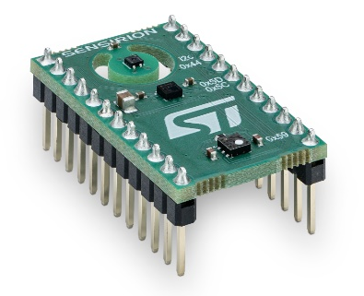

1 产品描述
SENSEVAL-SCB4XV1
适用于SHT4x温湿度传感器，SGP40 VOC传感器和ST LPS22DF气压传感器的评估开发板

该评估板由SHT40温湿度传感器、SGP40 VOC传感器和ST LPS22DF气压传感器组成，并与ST DIL 24插座兼容。

用户可以通过Combo板测量和了解他们周围的室内空气质量，并轻松识别潜在的有害事件。

由STEVAL-MKI109V3主板组成，并与ST的X-NUCLEO-IKS01A3和X-NUCLEO-IKS02A1扩展板兼容。

SHT40特点：
- 精确度提高，现有包装升级
- 供电电压1.08 V ~ 3.6 V，超低功耗
- 专为大批量生产设计

SGP40 VOC传感器特点：
- 在单个芯片上集成传感器系统
- 可以大幅降低功耗，适用于电池驱动的应用
- SGP40芯片和VOC算法具有无与伦比的鲁棒性
- 符合健康建筑标准RESET®和WELL建筑标准™

内含:
- 1x SENSEVAL-SCB4XV1

2 相关资料
- Product launch package: https://partners.sensirion.com/document/139#/other/senseval-scb4xv1
- SENSEVAL-SCB4XV1: SENSEVAL-SCB4XV1-Evaluation board for SHT4x temperature and humidity, SGP40 VOC and STMicroelectronics LPS22DF barometric pressure sensors (sensirion.com)
- Datasheet SHT4x: https://sensirion.com/resource/datasheet/sht4x
- Datasheet SGP40: https://sensirion.com/resource/datasheet/sgp40
- REACH and RoHS declaration: https://sensirion.com/resource/certificate/sht/rohs_reach_hal-free
- User guides:
  - Transition guide for HTS221 to SHT4x: https://sensirion.com/resource/user_guide/transition-guide-hts221-sht4x
  - Technical Description SENSEVAL-SCB4XV1: https://sensirion.com/resource/user_guide/technical_escription_SENSEVAL-SCB4XV1
- Software:
  - AirQuality_SGP40 Application Description: https://github.com/STMicroelectronics/X-CUBE-MEMS1/tree/main/Projects/NUCLEO-L152RE/Applications/CUSTOM/AirQuality_SGP40
  - SHT4x driver for STs Nucleo F103RB board with the X-NUCLEO-IKS02A1 shield: https://github.com/Sensirion/nucleo-i2c-sht4x
- Pictures (no login required):
    - SENSEVAL-SCB4XV1: https://brand.sensirion.com/share/fYEPS5DVQAypPiSaKo9R
    - SENSEVAL-SCB4XV1 (with shadow): https://brand.sensirion.com/share/yYVq4995Ryezxs54cqU4
    - SENSEVAL-SCB4XV1 (packaging + overview): https://brand.sensirion.com/share/eeTJ6Ma1iERZPenKMwHf

