1 Product description
2 Related material
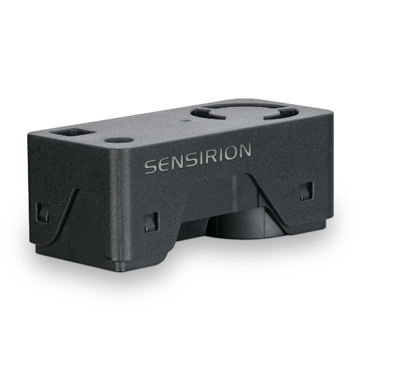

1 Product description
SEN62 sensing platform for PM and RH/T measurements
Experience the future of air quality sensing with the compact and powerful SEN62. It combines multiple sensors in a never-before-seen form factor and can measure up to six environmental parameters (PM1, PM2.5, PM4, PM10, T, RH). The innovative design simplifies integration, reduces costs, and allows for customization. At the core of the SEN62 is a brand-new, miniaturized, MEMS-based particulate matter sensing component – the SPS6x.
Features:
- All-in-one air quality sensor module
- On-board algorithms
- Compliant with IAQ standards RESET®, WELL Building Standard™
Benefits:
- Combination of multiple sensors
- Compact form factor
- Simplified integration
- Cost-efficient
- Short time to market

Applications:
- Air Purifier
- Copier machines
- 3D printers

Applications requiring compliance with IAQ standards – such as RESET®, WELL Building Standard™ and California Title 24 Building Energy Efficiency Standards – are well served by the SEN62.

2 Related material
- Product launch package: SEN62 - NPIs - PARTNERS @ Sensirion
- SEN62 product page: SEN62 - Sensing platform for PM and RH/T measurements
- Datasheet: https://sensirion.com/resource/datasheet/SEN6x
- Application notes:
  - https://sensirion.com/resource/application_note/compliance_VOC_sensors_building_standards
  - https://sensirion.com/resource/application_note/SEN6x_mechanical_design_assembly_guidelines
- Guides:
  - https://sensirion.com/resource/sen6x-limits
  - https://sensirion.com/resource/sen6x-handling
  - https://sensirion.com/resource/sen6x-int-heater
  - https://sensirion.com/resource/sen6x-spec-statement
  - https://sensirion.com/resource/SEN6x-temp-compensation
- REACH and RoHS declaration: https://sensirion.com/resource/certificate/pm/reach_rohs
- Particulate matter flyer: https://sensirion.com/resource/flyer-pm
- IAQ brochure: https://sensirion.com/resource/flyer/iaq/brochure
- Pictures SEN6x (no Login required):
  - SEN6x: https://brand.sensirion.com/share/4BDokbi7iPGqTqSwMEGY
  - SEN6x (shadow): https://brand.sensirion.com/share/BVTvFJD67Lu7vPxvQW51
  - SEK-SEN6x (plugged in): https://partners.sensirion.com/share/sBfK8UcDsgmZvXyX7XTm
  - SEK-SEN6x (plugged out): https://partners.sensirion.com/share/syTsJAKdHYSt6TjpCH6G
  - SEK-SEN6x cables: https://partners.sensirion.com/share/hWbNTJ45fgmPraq9zPDA

