1 产品描述
2 相关资料

产品描述
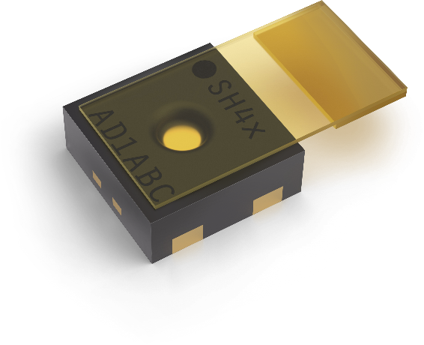
SHT40-AD1P-R2 ±1.8% / max. ±3.5% RH 数字温湿度传感器带保护盖
SHT40-AD1P-R2是第四代数字温湿度传感器，精度达±1.8%RH（max.±3.5%）和 ±0.2°C。该传感器配备标准I2C接口和固定的0x45 I2C地址，可确保无缝集成到各种应用中。其创新之处在于可拆卸保护盖以及 DFN 外壳，增强了在苛刻环境下传感器的耐用性和灵活性。SHT40-AD1P-R2 集紧凑外形、可靠性和创新传感技术于一身，是大批量应用的理想之选。
SHT41-AD1P-R2 ±1.8% / max. ±2.5% RH 数字温湿度传感器带保护盖
SHT41-AD1B-R2 是第四代数字温湿度传感器，精度达 ±1.8%RH（max.±2.5%）和 ±0.2°C。该传感器配备标准I2C接口和固定的 0x45 I2C地址，可确保无缝集成到各种应用中。其创新之处在于可拆卸保护盖以及 DFN 外壳，增强了在苛刻环境下的耐用性和灵活性。SHT41-AD1B-R2 集紧凑外形、可靠性和创新传感技术于一身，是大批量应用的理想之选。
特点:
- 第 4 代数字温湿度传感器
- 精度 ±1.8%RH 和 ±0.2°C
- 标准 I2C 接口
- DFN 外壳，设计紧凑、坚固耐用

优势:
- 外形紧凑
- 易于集成到各种应用中
- 适合大批量应用，性能稳定

应用:
- 暖通空调和家电
- 需要保护传感元件的制造工艺

相关资料
- Product launch package: SHT4x protective cover - NPIs - PARTNERS @ Sensirion
- SHT40-AD1P-R2 product page: SHT40-AD1P-R2-±1.8% / max. ±3.5% RH digital humidity and temperature sensor with protective cover
- SHT41-AD1P-R2 product page: SHT41-AD1P-R2-±1.8% / max. ±2.5% RH digital humidity and temperature sensor with protective cover
- Datasheet: https://sensirion.com/resource/datasheet/sht4x
- Application notes:
  - Handling instructions SHT: https://sensirion.com/resource/user_guide/sht/handling_instructions
  - Heater decontamination SHT4xX: https://sensirion.com/resource/application_note/sht4xx/heater_decontamination
  - Humidity at a glance: https://sensirion.com/resource/application_note/sht/glance
  - Introduction to humidity: https://sensirion.com/resource/application_note/sht/introduction
  - Specification statement and testing humidity sensors: https://sensirion.com/resource/application_note/sht/specification_sensors
  - Testing at ambient conditions SHT: https://sensirion.com/resource/application_note/testing_ambient_conditions/sht
- REACH and RoHS declaration: https://sensirion.com/resource/certificate/sht/rohs_reach_hal-free
- Design guide: https://sensirion.com/resource/user_guide/sht/design_in
- Humidity product flyer: https://sensirion.com/resource/flyer/humidity_sensors
- Pictures SHT4x protective cover (no Login required):
  - SHT4x protective cover top: https://brand.sensirion.com/share/gAJruYBYXisN3pA4xgEZ
  - SHT4x protective cover top (no shadow): https://brand.sensirion.com/share/eCAWxVmQFUdxuMi4YEtB

