1 Product description
2 Related material

1 Product description
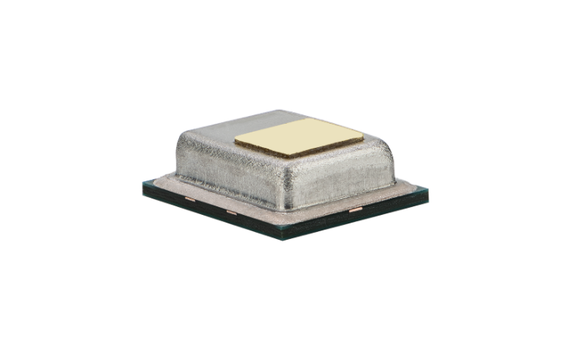
STCC4 CO₂ sensor with unmatched form factor for indoor air quality applications
STCC4 offers one of the smallest form factors on the market for direct measurement of CO2, unlocking new applications previously limited by size and cost constraints. Designed for seamless integration into compact electronic devices, the sensor is a groundbreaking newcomer in the CO2 sensor market.
Utilizing the latest technological advancements in thermal conductivity sensing, the fully factory calibrated STCC4 provides the accuracy needed for indoor air quality applications at a low current consumption. Both accurate signal compensation and monitoring of relevant indoor environmental parameters are achieved when STCC4 is combined with our industry-leading temperature and humidity sensors. Optimized for high volume assembly through its SMD design and tape & reel packaging, it is suitable for a wide range of applications, including indoor air quality monitors, smart thermostats, air conditioners and much more.

Features:
- Thermal conductivity sensing technology RH/T, PM (1, 2.5, 4, 10), VOC and NOx, CO2 outputs
- Small footprint of 4 × 3 × 1.2 mm3
- Current consumption of 950µA
- SMD soldering, tape & reel packaging
- Digital I2C interface

Benefits:
- Direct measurement of CO₂ concentration
- Facilitates space-efficient design-in
- Enables low power applications
- High reliability
- Straight-forward design-in
- Simple sensor communication
Applications:
- Smart speakers
- Smart thermostats
- Air conditioners
- Indoor air quality monitors

SEK-STCC4 Evaluation kit for CO2 sensor STCC4

The SEK-STCC4, with an integrated STCC4 on a development board, enables fast and flexible testing for various applications.

Includes:
1x STCC4 development board
1x adapter cable
1x jumper wire set
1x SEK-SensorBridge required

2 Related material
- Product launch package: https://partners.sensirion.com/document/139#/co2/stcc4-1
- STCC4 product page: STCC4 - CO₂ sensor with unmatched form factor for indoor air quality applications
- SEK-STCC4 product page: sensirion.com/products/catalog/SEK-STCC4
- Datasheet: https://sensirion.com/resource/datasheet/STCC4
- REACH and RoHS declaration: https://sensirion.com/resource/certificate/reach_rohs_stcc4
- One-pager smart thermostats: Onepagers - PARTNERS @ Sensirion
- Carbon Dioxide product flyer: https://sensirion.com/resource/flyer-co2
- IAQ brochure: https://sensirion.com/resource/flyer/iaq/brochure
- Pictures (no Login required): https://sensirion.com/resource/certificate/reach_rohs_stcc4
  - STCC4: https://brand.sensirion.com/share/ucWKwf2YkpArRScXeiQJ
  - SEK-STCC4: https://brand.sensirion.com/share/JQGYTLsjCFXcsDHdFgZr

