1 Product description
2 Related material

Product description
SFC6000D Mass Flow Controllers &
SFM6000D Mass Flow Meters

The SFC6000D Mass Flow Controllers and SFM6000D Mass Flow Meters impress with an unbeatable price-performance ratio and a very attractive delivery time of 8 weeks.
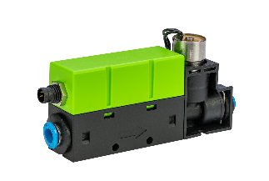
The SFC6000D Mass Flow Controller is very small and light and therefore allows the customer to optimize their devices in terms of size and weight. This is a decisive advantage, especially for portable devices. Furthermore, it offers great performance in terms of repeatability, accuracy, control range and speed. The SFC6000D is highly integrated and has a very robust supply chain due to the very low number of electronic components used.

Based on the thermal-mass measurement principle and using our proven CMOSens® MEMS technology, Sensirion builds radical mass flow controllers with best-in-class performance and speed, which, unlike most other devices on the market, do not drift and do not require in-service re-calibration.
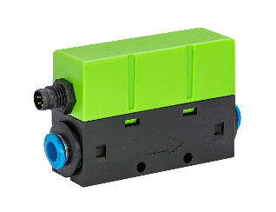
Additionally, Sensirion is offering a valve-less sister variant of the SFC6000D, the SFM600D Mass Flow Meter with the same performance at an even lower price.

The SFC6000D and SFM6000D are available in the following versions:

- SFC6000D-5slm: flow rates up to 5 slm
- SFC6000D-20slm: flow rates up to 20 slm
- SFC6000D-50slm: flow rates up to 50 slm
- SFM6000D-5slm: flow rates up to 5 slm
- SFM6000D-20slm: flow rates up to 20 slm
- SFM6000D-50slm: flow rates up to 50 slm

Features & benefits
- Unbeatable price-performance ratio with 2% / 0.2% accuracy / repeatability
- Opens up applications where a mass flow controller is traditionally too costly
- Very wide control range (0.2% - 100% full scale)
- Calibrated for multiple gasses with exchangeable fittings
- Digital RS485 interface
- Compact and lightweight - Freedom of design and space-saving
- Integrated design with very few electronic components
- Very robust supply chain to enhance supply safety
- No drift and no re-calibration required in the field
- EK-F5x evaluation kit for quick and easy testing

Applications
- Semiconductor: front opening unified pods (FOUP), glass coating and treatment
- Analytical instruments: gas chromatography, bioreactors
- Medical equipment: anesthesia, ventilation, heart-lung machines, N2O therapy
- Industrial automation
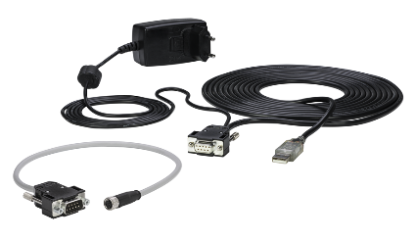
New Evaluation Kit EK-F5x SFC/SFM6xxx and SFC/SFM5xxx

Sensirion replaces the Evaluation Kit EK-F5x with a new, extended version for SFC6xxx Mass Flow Controllers and SFM6xxx Mass Flow Meters. The Evaluation Kit is fully backward-compatible with SFC5xxx and SFM5xxx series.

The new EK-F5x SFC/SFM6xxx and SFC/SFM5xxx Evaluation Kit includes:
- DB9 to USB + power plug cable
- DB9 to M8 cable (NEW)
- SFC5500, SFM5500 compatibility
- SFC6000, SFM6000 compatibility (NEW)
- Quick start guide SFC5500
- Quick start guide SFC6000 (NEW)

Sensors need to be purchased separately.

- EK-F5x (old version) article no: 1-101006-01
- EK-F5x SFC/SFM6xxx and SFC/SFM5xxx (new version) article no: 3.000.912

Please return the old Evaluation Kit EK-F5x to Sensirion and we will refund the amount.

More information about can be found in the attached information letter as well as on Sensirion’s Partner’s Access: https://partners.sensirion.com/document/140-/end-of-life/ek-f5x - /end-of-life/ek-f5x.

Related material
- Product launch package: SFC6000D & SFM6000D - NPI's - PARTNERS @ Sensirion
- Product pages:
  - SFC6000D-5slm: https://sensirion.com/products/catalog/SFC6000D-5slm/
  - SFC6000D-20slm: https://sensirion.com/products/catalog/SFC6000D-20slm/
  - SFC6000D-50slm: https://sensirion.com/products/catalog/SFC6000D-50slm/
  - SFM6000D-5slm: https://sensirion.com/products/catalog/SFM6000D-5slm/
  - SFM6000D-20slm: https://sensirion.com/products/catalog/SFM6000D-20slm/
  - SFM6000D-50slm: https://sensirion.com/products/catalog/SFM6000D-50slm/
  - Evaluation Kit EK-F5x SFC/SFM6xxx and SFC/SFM5xxx: https://sensirion.com/us/products/catalog/EK-F5x/
- Replacement of EK-F5x: https://partners.sensirion.com/document/140-/end-of-life/ek-f5x - /end-of-life/ek-f5x
- Preliminary Datasheet: https://sensirion.com/resource/datasheet/sfc6000d_sfm6000d
- REACH and RoHS declaration Mass Flow Controllers: coming soon
- REACH and RoHS declaration Mass Flow Meters: https://sensirion.com/resource/certificate/sfm/reach_rohs
- Mass Flow Controllers selection guide: https://sensirion.com/resource/application_note/mfc/selection_guide
- Quick start guide: https://sensirion.com/resource/quick_start/SFC6000_SFM6000
- Mass Flow Controllers brochure: https://sensirion.com/resource/flyer/mass_flow_controllers
- RS485 description: coming soon
- I²C interface description: coming soon
- Application note “Exchange fittings”: https://sensirion.com/resource/application_note/sfc6000_sfm6000/fittings
- Video SFC6000 Mass Flow Controller: https://youtu.be/zzILEeQ2RYk
- Pictures (no login required):
  - SFC6000D: https://brand.sensirion.com/s/1277/koziAZzg
  - SFM6000D: https://brand.sensirion.com/s/1277/BKGsTV6L
  - Evaluation Kit EK-F5x SFC/SFM6xxx and SFC/SFM5xxx: https://brand.sensirion.com/s/44/t81VtEjh

