1 产品描述
2 相关资料

产品描述
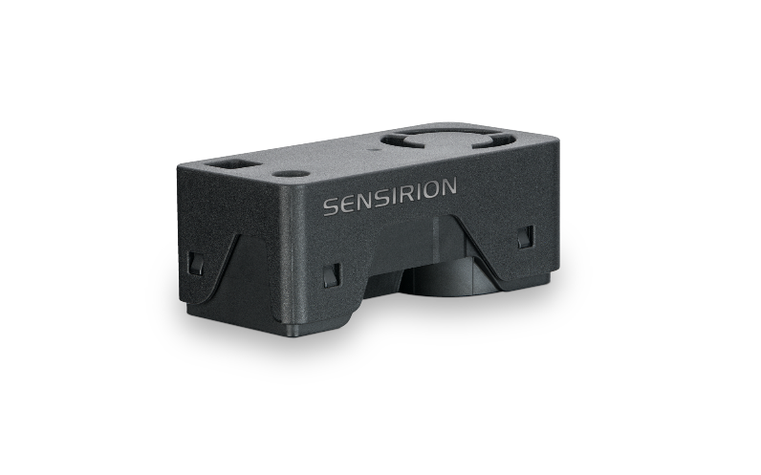
通过SEN66传感器模组简化室内空气质量检测，可用于PM、RH/T、VOC、Nox和CO2测量

通过小巧而强大的SEN66传感器模组体验空气质量传感的未来。SEN66以前所未有的紧凑外形集成了多个传感器，可以测量多达9种环境参数(PM1, PM2.5, PM4, PM10, T, RH, VOC指数，NOx指数，CO2)，其核心组件是一颗全新小型化的，基于mems技术的颗粒物传感器——SPS6x。创新的设计大大简化了集成，降低了成本，同时支持通过SEN6x系列中的不同传感器进行定制。

特点:
- 多合一空气质量传感器模组
- RH/T、PM（1、2.5、4、10）、VOC 和 NOx、CO2 输出
- 板载算法
- 符合RESET®、WELL Building Standard™和California Title 24 Building Energy Efficiency Standard等室内空气质量标准

优势：
- 多合一传感器模组
- 外形紧凑
- 简化集成
- 成本效益高
- 快速上市

应用：
- 室内空气质量监测
- 电子烟检测
- 智能建筑
- 室内传感器
- 空气净化器

SEN66 能够很好地满足需要符合相关 IAQ 标准的应用。（如 RESET®、WELL Building Standard™和California Title 24 Building Energy Efficiency Standards

相关资料
- SEN66 product page: SEN66-Sensing platform for PM, RH/T, VOC, Nox and CO2 measurements (sensirion.com)
- SEK-SEN66: SEK-SEN66-Evaluation kit SEN60, SEN65, SEN66 (sensirion.com)
- Datasheet: https://sensirion.com/resource/datasheet/SEN6x-distribution
- Application notes:
  - How can I integrate Sensirion’s VOC and NOx sensors into my air purifier? https://sensirion.com/resource/application_note/voc_nox_sensor_integration
  - Is it possible to map the output of a MOX sensor to a norm? https://sensirion.com/resource/application_note/output_mox_sensor
  - What are oxidizing gases? https://sensirion.com/resource/application_note/oxidizing_gases
  - What are reducing gases? https://sensirion.com/resource/application_note/reducing_gases
  - What is a metal oxide (MOX) sensor? https://sensirion.com/resource/application_note/mox_sensor
  - What is Sensirion’s NOx Index? https://sensirion.com/resource/application_note/nox_index
  - What is Sensirion’s VOC Index? https://sensirion.com/resource/application_note/voc_index
  - Compliance of Sensirion’s VOC Sensors with RESET and WELL: https://sensirion.com/resource/application_note/compliance_VOC_sensors_building_standards
  - Sensor specification statement Particulate Matter Sensors: https://sensirion.com/resource/application_note/pm/sensor_specification
- REACH and RoHS declaration: https://sensirion.com/resource/certificate/pm/reach_rohs
- Particulate matter flyer: https://sensirion.com/resource/flyer-pm
- IAQ brochure : https://sensirion.com/resource/flyer/iaq/brochure
- Pictures SEK-SEN6x (no Login required):
  - SEN66: https://brand.sensirion.com/share/BVTvFJD67Lu7vPxvQW51
  - SEN66(with shadow): https://brand.sensirion.com/share/4BDokbi7iPGqTqSwMEGY

