1 Product description
2 Related material

Product description
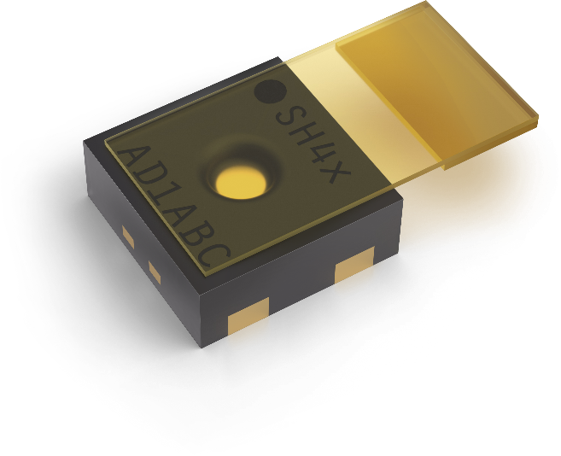
SHT40-AD1P-R2 ±1.8% / max. ±3.5% RH digital humidity and temperature sensor with protective cover
The SHT40-AD1P-R2 is a 4th-generation digital humidity and temperature sensor, offering accuracy of ±1.8%RH (max. ±3.5%) and ±0.2°C. Equipped with a standard I2C interface and a fixed 0x45 I2C address, this sensor ensures seamless integration into various applications. Its innovative design includes a removable protective cover as well as DFN housing, enhancing durability and flexibility for demanding environments. Ideal for high-volume applications, the SHT40-AD1P-R2 combines a compact form factor, reliability, and innovative sensing technology.
SHT41-AD1P-R2 ±1.8% / max. ±2.5% RH digital humidity and temperature sensor with protective cover
The SHT41-AD1B-R2 is a 4th-generation digital humidity and temperature sensor, offering high accuracy of ±1.8%RH (max. ±2.5%) and ±0.2°C. Equipped with a standard I2C interface and a fixed 0x45 I2C address, this sensor ensures seamless integration into various applications. Its innovative design includes a removable protective cover as well as DFN housing, enhancing durability and flexibility for demanding environments. Ideal for high-volume applications, the SHT41-AD1B-R2 combines a compact form factor, reliability, and innovative sensing technology.
Features:
- 4th-generation digital humidity and temperature sensor
- Accuracy of ±1.8%RH and ±0.2°C
- Standard I2C interface
- DFN housing for compact and robust design

Benefits:
- Compact form factor
- Easy integration into various applications
- Ideal for high-volume applications with consistent performance

Applications:
- HVAC and appliances
- Manufacturing processes requiring protection in the sensing element

Related material
- Product launch package: SHT4x protective cover - NPIs - PARTNERS @ Sensirion
- SHT40-AD1P-R2 product page: SHT40-AD1P-R2-±1.8% / max. ±3.5% RH digital humidity and temperature sensor with protective cover
- SHT41-AD1P-R2 product page: SHT41-AD1P-R2-±1.8% / max. ±2.5% RH digital humidity and temperature sensor with protective cover
- Datasheet: https://sensirion.com/resource/datasheet/sht4x
- Application notes:
  - Handling instructions SHT: https://sensirion.com/resource/user_guide/sht/handling_instructions
  - Heater decontamination SHT4xX: https://sensirion.com/resource/application_note/sht4xx/heater_decontamination
  - Humidity at a glance: https://sensirion.com/resource/application_note/sht/glance
  - Introduction to humidity: https://sensirion.com/resource/application_note/sht/introduction
  - Specification statement and testing humidity sensors: https://sensirion.com/resource/application_note/sht/specification_sensors
  - Testing at ambient conditions SHT: https://sensirion.com/resource/application_note/testing_ambient_conditions/sht
- REACH and RoHS declaration: https://sensirion.com/resource/certificate/sht/rohs_reach_hal-free
- Design guide: https://sensirion.com/resource/user_guide/sht/design_in
- Humidity product flyer: https://sensirion.com/resource/flyer/humidity_sensors
- Pictures SHT4x protective cover (no Login required):
  - SHT4x protective cover top: https://brand.sensirion.com/share/gAJruYBYXisN3pA4xgEZ
  - SHT4x protective cover top (no shadow): https://brand.sensirion.com/share/eCAWxVmQFUdxuMi4YEtB

