1 Product description
2 Related material

1 Product description
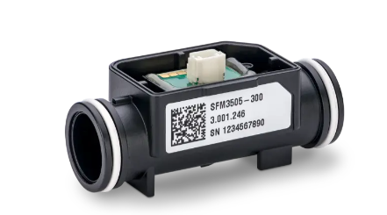
SFM3505-300 next generation compact flow sensor
Next generation compact flow sensor, 2.3% m.v. accuracy
The SFM3505-300 is part of our next-generation compact digital flow meter family, succeeding the proven SFM3119 and SFM3100. Featuring a completely re-engineered architecture, it delivers best-in-class performance with ultra-low noise and high accuracy across an extended flow range from –150 to +300 slm. The sensor is offered in two performance tiers, SFM3505-300 with standard (2.3% m.v.) and SFM3505-300-X with high (1.5% m.v.) accuracy.
Features:
- Built on Sensirion’s 5th-generation CMOSens® Technology
- Integration of sensor element and advanced signal processing on a single microchip
- Fast, stable, fully calibrated digital output via standard I²C interface
- Calibrated for air and oxygen
- Optimized flow channel design for reduced pressure drop

Benefits:
- Best-in-class performance with ultra-low noise and high accuracy
- Extended flow range from –150 to +300 slm
- Long-term reliability Precise measurements under varying conditions due to on-chip temperature compensation
- Minimal pressure drop across the dynamic range

Applications:
- mechanical ventilation
- anesthesia
- gas mixing systems

SFM3505-300-X next generation compact flow sensor, 1.5% m.v. accuracy
The SFM3505-300-X is part of our next-generation compact digital flow meter family, succeeding the proven SFM3119 and SFM3100. Featuring a completely re-engineered architecture, it delivers best-in-class performance with ultra-low noise and high accuracy across an extended flow range from –150 to +300 slm. The sensor is offered in two performance tiers, SFM3505-300 with standard (2.3% m.v.) and SFM3505-300-X with high (1.5% m.v.) accuracy.
Features:
- Built on Sensirion’s 5th-generation CMOSens® Technology
- Integration of sensor element and advanced signal processing on a single microchip
- Fast, stable, fully calibrated digital output via standard I²C interface
- Calibrated for air and oxygen
- Optimized flow channel design for reduced pressure drop

Benefits:
- Best-in-class performance with ultra-low noise and high accuracy
- Extended flow range from –150 to +300 slm
- Long-term reliability Precise measurements under varying conditions due to on-chip temperature compensation
- Minimal pressure drop across the dynamic range

Applications:
- mechanical ventilation
- anesthesia
- gas mixing systems

SEK-SFM3505 gas flow sensor evaluation kit SFM3505
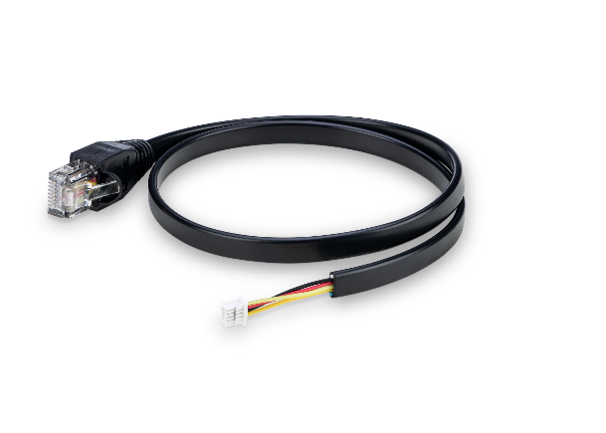
Enables the evaluation of any version of the SFM3505 sensor.
Included:
- 1 cable compatible with the SFM3505 sensor and with Sensirion’s SensorBridge
- What you need additionally:
- Sensor to evaluate: SFM3505-300, SFM3505-300-X
- Sensor bridge
- Download Control Center

2 Related material
- Product launch package: SFM3505 - NPIs - PARTNERS @ Sensirion
- SFM3505-300 product page: SFM3505-300 - Next generation compact flow sensor, 2.3% m.v. accuracy
- SFM3505-300-X product page: SFM3505-300-X - Next generation compact flow sensor, 1.5% m.v. accuracy
- SEK-SFM3505 evaluation cable product page: https://sensirion.com/products/catalog/SEK-SFM3505
- Datasheet: https://sensirion.com/resource/datasheet/sfm3505
- Engineering guide: https://sensirion.com/resource/user_guide/sfm/engineering_guide
- Drivers for SFM3505: https://sensirion.com/resource/drivers_sfm3505
- Calibration certification gas flow sensors: https://sensirion.com/resource/certificate/gas_flow
- Application notes:
  - Handling instructions SFM3xxx: https://sensirion.com/resource/application_note/sfm3xxx/handling_instructions
  - Reference and flow conversions: https://sensirion.com/resource/application_note/sfm/reference_flow_conversions
  - Reference and flow conversions calculator: https://sensirion.com/resource/application_note/sfm/reference_flow_conversions_calculator
  - Selection guide gas flow sensors: https://sensirion.com/resource/application_note/sfm/selection-guide
- REACH and RoHS declaration: https://sensirion.com/resource/certificate/sfm/reach_rohs
- Gas flow sensors brochure: https://sensirion.com/resource/flyer/gas_flow_sensors
- Pictures SFM3505 (no Login required):
  - SFM3505 (front): https://brand.sensirion.com/share/v1DLdz2wJCmx2rXueoNn
  - SFM3505 (back): https://brand.sensirion.com/share/oAzW21b8uHicGm3aaP1a
  - SEK-SFM3505 evaluation cable: https://brand.sensirion.com/share/uePMnXPhP3DjyCvENCsK

