1 产品介绍
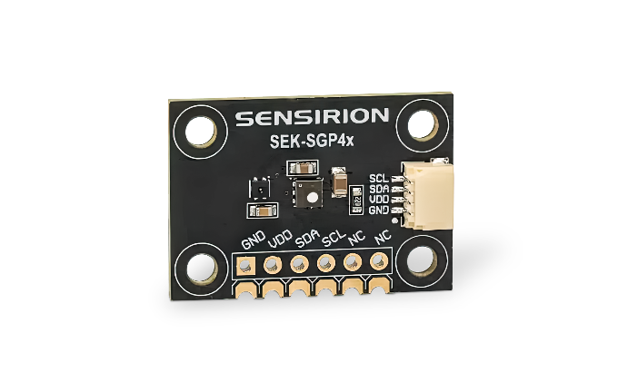
2 相关材料

1 产品介绍
用于 SGP40 和 SGP41 VOC 与 NOx 气体传感器的 SEK-SGP4x 评估套件
SEK-SGP4x 传感器评估套件专为工程师和开发人员设计，支持快速原型开发，并便于将 Sensirion 的 VOC 和 NOx 气体传感器集成到各类应用中。该套件同时支持 SGP40 和 SGP41 两种传感器，并集成了一颗 SHT41 温湿度传感器。
与 SEK-SVM4x 评估套件不同，该评估板不包含板载微控制器，仅输出原始传感器信号（SRAW）。如需获取 VOC Index、NOx Index 或其他处理后的信号，可通过 Sensirion 的 SEK-SensorBridge 将 SEK-SGP4x 连接至 PC，并使用 SEK-ControlCenter 软件进行读取和分析。
产品特点:
- 支持快速传感器评估与原型开发
- 单一传感器芯片即可检测多种室内气体污染物
- 符合健康建筑相关标准 RESET® 和 WELL Building Standard™

套件包含:
- 1x SGP4x 开发板
- 1x 适配连接线
- 1x 跳线套件

产品应用:
- 空气净化器
- 其他空气处理设备及室内空气质量监测仪

2 相关材料
- Product launch package: https://partners.sensirion.com/document/139#/voc-and-nox/sek-sgp4x-1
- SEK-SGP4x product page: https://sensirion.com/products/catalog/SEK-SGP4x
- Datasheet SGP40: https://sensirion.com/resource/datasheet/sgp40
- Datasheet SGP41: https://sensirion.com/resource/datasheet/sgp41
- Application notes:
  - https://sensirion.com/resource/application_note/compliance_VOC_sensors_building_standards
  - https://sensirion.com/resource/application_note/improve_air_quality
  - https://sensirion.com/resource/application_note/voc_nox_sensor_integration
  - https://sensirion.com/resource/application_note/make_air_purifier_smart
  - https://sensirion.com/resource/application_note/output_mox_sensor
  - https://sensirion.com/resource/application_note/oxidizing_gases
  - https://sensirion.com/resource/application_note/reducing_gases
  - https://sensirion.com/resource/application_note/mox_sensor
- Guides:
  - https://sensirion.com/resource/user_guide/sgp41
  - https://sensirion.com/resource/user_guide/sgp4x/testing
- REACH and RoHS declaration: https://sensirion.com/resource/certificate/sgp/rohs_reach_hal-free
- IAQ brochure: https://sensirion.com/resource/flyer/iaq/brochure
- SGP4x-EK flyer: https://sensirion.com/resource/flyer/sek-sgp4x
- VOC and NOx product flyer: https://sensirion.com/resource/flyer/gas_sensors
- Pictures SEK-SGP4x (no Login required):
  - SEK-SGP4x: https://brand.sensirion.com/share/kMzi71U57dqiYSp4oYpu

