1 Product description
2 Related material

Product description
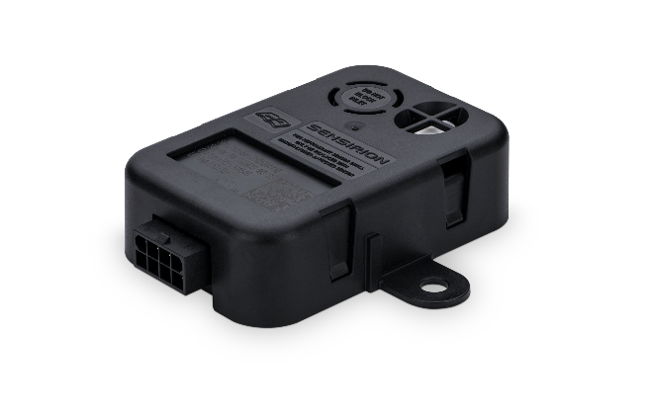
SGD43S-M3-Sx flexible and complete refrigerant leakage detection system for modern HVAC and refrigeration systems
The SGD43S-M3-Sx is part of our SGD4x series of A2L refrigerant detection products, specifically designed for the HVACR industry as a complete refrigerant detection system (RDS). It is based on the thermal conductivity measurement principle and features a dual contact relay output that can trigger a signal relay to start a blower, switch off the load or warn a control board. Easy integration and installer-friendly feedback is enabled by a status-indicating LED for quick visual feedback.
With its fast response time and broad compatibility with A2L refrigerants thanks to its versatile multi-refrigerant calibration, it is an essential component for both residential and commercial HVACR systems.
The SGD43S-M3-S5 ensures effective leak detection and complies with stringent industry standards, including UL 60335-2-40 and UL 60335-2-89. It offers dual calibration in a single device for R-454B and R-32 for HVAC applications.
The SGD43S-M3-S7 ensures effective leak detection and complies with stringent industry standards, including UL 60335-2-40 and UL 60335-2-89. The single unit is triple calibrated for R-454A, R-454C and R-455A in refrigeration applications.
Features:
- Wide refrigerant compatibility supports R32, R454A, R454B, R454C, and R455 refrigerants and is resistant to refrigerant poisoning
- Robust IP54 packaging
- No poisoning effects
- Expected lifetime of >15yrs
- Operational temperature of -40 to 185 °F (-40 to 85 °C)
- Operational humidity range of 0 to 100 %RH
- RH/T compensated
- Anti-condensation measures
- Self-monitoring

Benefits:
- Compliant with stringent industry standards, including UL 60335-2-40 and UL 60335-2-89
- Easy integration
- Status-indicating LED indicating quick visual feedback

Applications:
- Residential and commercial HVAC systems
- Heat pumps
- Refrigeration equipment

Related material
- Product launch package: SGD43S-M3-Sx - NPIs - PARTNERS @ Sensirion
- SGD43S-M3-S5 product page: SGD43S-M3-S5 - Flexible and complete refrigerant leakage detection system for modern HVAC systems
- SGD43S-M3-S7 product page: SGD43S-M3-S7 - Flexible and complete refrigerant leakage detection system for modern refrigeration systems
- Datasheet: https://sensirion.com/resource/datasheet/SGD43S-M3-Sx
- Guides:
  - Design-in Guide SGD43S-M3-Sx﻿﻿: https://sensirion.com/resource/design-in-guide_SGD43S-M3-Sx
  - ﻿﻿Starting Guide SGD43S-M3-Sx﻿﻿: https://sensirion.com/resource/user_guide/SGD43S-M3-Sx
  - ﻿﻿Handling instructions SGD43S-M3-Sx﻿﻿: https://sensirion.com/resource/handling_instructions_SGD43S-M3-Sx
  - ﻿﻿Packaging specifications SGD43S-M3-Sx﻿﻿: https://sensirion.com/resource/packing_specifications_SGD43S-M3-Sx
  - ﻿﻿Multi-Refrigerant Calibration SGD43S-M3-Sx﻿﻿: https://sensirion.com/resource/packing_specifications_SGD43S-M3-Sx
- REACH and RoHS declaration: https://sensirion.com/resource/certificate/sgd43S-M3-Sx/reach_rohs
- One-pagers:
  - A2L refrigerant leak detection for HVAC: https://brand.sensirion.com/share/AZNzz1D58v8yFn5qCNmc
  - A2L refrigerant leak detection for refrigeration: https://brand.sensirion.com/share/3HvFmXrJEBpHY3jS5NaG
- Product flyer SGD43S-M3-Sx: https://sensirion.com/resource/sgd43s
- Picture SGD43S-M3-Sx (no Login required): https://brand.sensirion.com/share/5KDh4afaTFDmPgjGcEp1

