1 Product description
2 Related material

Product description
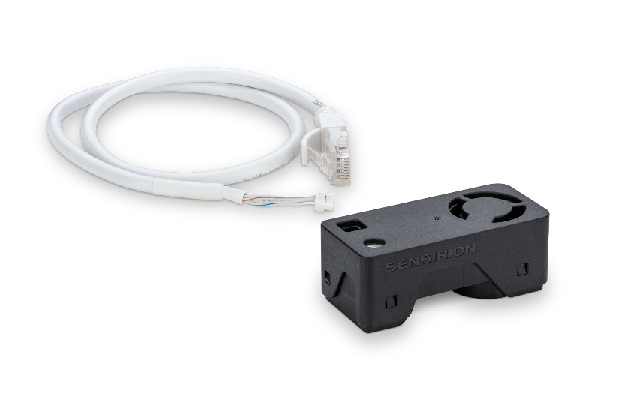
SEK-SEN66 evaluation kit for the all-in-one air quality sensor modules SEN60, SEN65, SEN66
Experience the future of air quality sensing with the compact and powerful SEN66. It combines multiple sensors in a never-before-seen form factor and can measure up to nine environmental parameters (PM1, PM2.5, PM4, PM10, T, RH, VOC Index, NOx Index, CO2). The innovative design simplifies integration, reduces costs, and allows
for customization through the different variants within the SEN6x family. At the core of the SEN66 is a brand-new, miniaturized, MEMS-based particulate matter sensing component – the SPS6x.
The SEK-SEN66 evaluation kit has been designed for easy and cost-efficient evaluation of Sensirion’s SEN66, SEN65 and SEN60 for all-in-one air quality sensing.
It contains a SEN66 all-in-one air quality sensor module and an adapter cable to connect the SEN66 to the SEK-SensorBridge for easy evaluation of the sensor with Sensirion’s SEK-ControlCenter viewer software. One jumper wire set and one adapter cable for Qwiic are also included enabling fast prototyping through the integration into existing platforms such as Arduino, Raspberry Pi, etc. In addition, Sensirion provides the drivers for these platforms as well.
Please note: The SEK-SensorBridge is not included in the evaluation kit and needs to be ordered separately.
Features:
- All-in-one air quality sensor module
- RH/T, PM (1, 2.5, 4, 10), VOC and NOx, CO2 outputs
- On-board algorithms
- Compliant with IAQ standards RESET®, WELL Building Standard™ and California Title 24 Building Energy Efficiency Standards

Benefits:
- Combination of multiple sensors
- Compact form factor
- Simplified integration
- Cost-efficient
- Short time to market

Applications:
- Indoor air quality monitoring
- Vape detection
- Smart buildings
- Room sensors
- Air purifiers

Applications requiring compliance with IAQ standards – such as RESET®, WELL Building Standard™ and California Title 24 Building Energy Efficiency Standards – are well served by the SEN66.

Related material
- Product launch package: SEK-SEN66 - NPIs - PARTNERS @ Sensirion
- SEK-SEN66: SEK-SEN66-Evaluation kit SEN60, SEN65, SEN66 (sensirion.com)
- SEN66 product page: SEN66-Sensing platform for PM, RH/T, VOC, Nox and CO2 measurements (sensirion.com)
- SEN65 product page: SEN65-Sensing platform for PM, RH/T, VOC and NOx measurements (sensirion.com)
- SEN60 product page: SEN60-Sensing platform for PM measurements (sensirion.com)
- Datasheet: https://sensirion.com/resource/datasheet/SEN6x
- Application notes:
  - How can I integrate Sensirion’s VOC and NOx sensors into my air purifier? https://sensirion.com/resource/application_note/voc_nox_sensor_integration
  - Is it possible to map the output of a MOX sensor to a norm? https://sensirion.com/resource/application_note/output_mox_sensor
  - What are oxidizing gases? https://sensirion.com/resource/application_note/oxidizing_gases
  - What are reducing gases? https://sensirion.com/resource/application_note/reducing_gases
  - What is a metal oxide (MOX) sensor? https://sensirion.com/resource/application_note/mox_sensor
  - What is Sensirion’s NOx Index? https://sensirion.com/resource/application_note/nox_index
  - What is Sensirion’s VOC Index? https://sensirion.com/resource/application_note/voc_index
  - Compliance of Sensirion’s VOC Sensors with RESET and WELL: https://sensirion.com/resource/application_note/compliance_VOC_sensors_building_standards
- REACH and RoHS declaration: https://sensirion.com/resource/certificate/pm/reach_rohs
- Particulate matter flyer: https://sensirion.com/resource/flyer-pm
- Pictures SEK-SEN6x (no Login required):
  - SEK-SEN66 plugged out: https://brand.sensirion.com/share/syTsJAKdHYSt6TjpCH6G
  - SEK-SEN66 plugged out (with shadow): https://brand.sensirion.com/share/KgKpsUnNpmLYFPtqPC6J
  - SEK-SEN66 plugged-in: https://brand.sensirion.com/share/sBfK8UcDsgmZvXyX7XTm
  - SEK-SEN66 plugged-in (with shadow): https://brand.sensirion.com/share/pmAwL1WB9vUaMFjn5Prp
  - SEK-SEN66 cables: https://brand.sensirion.com/share/hWbNTJ45fgmPraq9zPDA
  - SEK-SEN66 cables (with shadow): https://brand.sensirion.com/share/nk6Q7UueWBpaq7J72hRt

