1 Product description
2 Related material

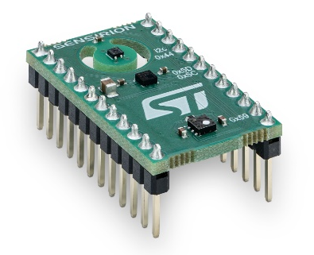

Product description
SENSEVAL-SCB4XV1
Evaluation and development board for SHT4x temperature and humidity, SGP40 VOC and STMicroelectroni cs LPS22DF barometric pressure

This Evaluation Board features a unique combination of SHT40 humidity and temperature sensor, SGP40 VOC sensor and an STMicroelectronics LPS22DF barometric pressure sensor and is compatible with the STMicroelectronics DIL 24 socket.

The Combo board allows the users to measure and understand the indoor air quality around them and easily identify potentially harmful events.

It is supported by the STEVAL-MKI109V3 motherboard and compatible with the X-NUCLEO-IKS01A3 and X-NUCLEO-IKS02A1 expansion boards from STMicroelectronics.

SHT40 features
- New standard with improved accuracies and established package
- 1.08 V to 3.6 V supply voltage and ultra-low power consumption
- Designed for high production volumes

SGP40 VOC sensor features
- complete sensor system on a single chip
- enables a drastic reduction in power consumption, making it suitable for battery-driven applications
- SGP40 chip and VOC algorithm feature unrivaled robustness
- compliant with healthy building standards RESET® and WELL Building Standard™

Includes
- 1x SENSEVAL-SCB4XV1

Related material
- Product launch package: https://partners.sensirion.com/document/139#/other/senseval-scb4xv1
- SENSEVAL-SCB4XV1: SENSEVAL-SCB4XV1-Evaluation board for SHT4x temperature and humidity, SGP40 VOC and STMicroelectronics LPS22DF barometric pressure sensors (sensirion.com)
- Datasheet SHT4x: https://sensirion.com/resource/datasheet/sht4x
- Datasheet SGP40: https://sensirion.com/resource/datasheet/sgp40
- REACH and RoHS declaration: https://sensirion.com/resource/certificate/sht/rohs_reach_hal-free
- User guides:
  - Transition guide for HTS221 to SHT4x: https://sensirion.com/resource/user_guide/transition-guide-hts221-sht4x
  - Technical Description SENSEVAL-SCB4XV1: https://sensirion.com/resource/user_guide/technical_escription_SENSEVAL-SCB4XV1
- Software:
  - AirQuality_SGP40 Application Description: https://github.com/STMicroelectronics/X-CUBE-MEMS1/tree/main/Projects/NUCLEO-L152RE/Applications/CUSTOM/AirQuality_SGP40
  - SHT4x driver for STs Nucleo F103RB board with the X-NUCLEO-IKS02A1 shield: https://github.com/Sensirion/nucleo-i2c-sht4x
- Pictures (no login required):
    - SENSEVAL-SCB4XV1: https://brand.sensirion.com/share/fYEPS5DVQAypPiSaKo9R
    - SENSEVAL-SCB4XV1 (with shadow): https://brand.sensirion.com/share/yYVq4995Ryezxs54cqU4
    - SENSEVAL-SCB4XV1 (packaging + overview): https://brand.sensirion.com/share/eeTJ6Ma1iERZPenKMwHf

